Sql pratical

Create type student as object

(

name varchar2(30),

phone varchar2(20)

);

create table student_table of student;

Describe student_table;

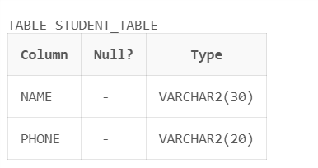

create type employee_t as object

(name varchar(30),

ssn varchar(11),

salary number,

member function raise_sal return number);

create type body employee_t as

member function raise_sal Return Number is

Begin

return salary*2;

end;

end;

create table emp2 of employee_t;

insert into emp2

values(employee_t('yash','12345',20000));

select * from emp2;

select e.raise_sal()from emp2 e;

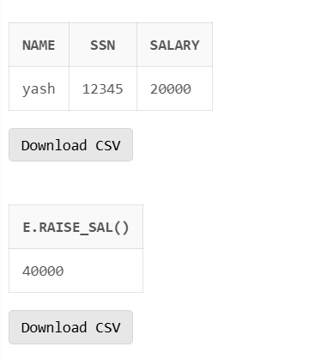

create type emp as object

(eid number, ename varchar2(10), emp_addr varchar2(10), doj date, salary number, MEMBER FUNCTION cal_sal RETURN number)not final;

CREATE TYPE BODY emp AS

MEMBER FUNCTION cal_sal RETURN number IS

BEGIN

RETURN salary;

END;

END;

CREATE TABLE employee OF emp;

INSERT INTO employee VALUES

(emp(1, 'Harshada', 'Ratnagiri', '14-AUG-2008', 20000));

SELECT * FROM employee;

DESCRIBE emp;

CREATE TYPE eng UNDER emp

(eng_type varchar2(10),

MEMBER FUNCTION emp_type RETURN varchar2);

CREATE TYPE BODY eng AS

MEMBER FUNCTION emp_type RETURN varchar2 IS

BEGIN

RETURN 'Engineer';

END;

END;

INSERT INTO engineer

VALUES(2, 'Anita', 'Ratnagiri', '12-DEC-2009', 15000, 'Senior');

SELECT e.cal_sal() from engineer e;

SELECT e.emp_type() from engineer e;